

软件学院

数据库报告：实验二算法实现

|  |  |
| --- | --- |
| 选课编号： | 113007 |
| 分组编号： | 24 |
| 姓名： | 程鹏宇 |
| 学号： | 3124336012 |
| 班级： | 1班 |
| 指导老师： | 白秀秀 |
| 完成日期： | 2024年11月31号 |

**目 录**

1. 索引 1

1.1线性散列索引的构建、检索、插入、删除的代码实现与测试 1

2. 并发控制 3

2.1冲突可串行性判别算法 3

2.2 基于时间戳的并发控制算法 5

3．完成Paxos协议的代码实现与测试 8

# 索引

## 1.1线性散列索引的构建、检索、插入、删除的代码实现与测试

class LinearHash:

    def __init__(self, initial_buckets=8):

        self.buckets = [{} for _ in range(initial_buckets)]

        self.bucket_count = initial_buckets

        self.split_index = 0

        self.threshold = 0.75  # 装填因子阈值

    def _hash(self, key, level=None):

        if level is None:

            level = self.bucket_count

        return hash(key) % level

    def _rehash(self):

        # 当前桶满了，需要分裂

        bucket_to_split = self.buckets[self.split_index]

        new_bucket = {}

        # 将要分裂的桶中的元素重新分配

        for key, value in bucket_to_split.items():

            new_index = self._hash(key, self.bucket_count * 2)

            if new_index < self.bucket_count:

                del self.buckets[new_index][key]

                self.buckets[new_index][key] = value

            else:

                new_bucket[key] = value

        # 更新桶数组

        self.buckets.append(new_bucket)

        self.bucket_count *= 2

        self.split_index += 1

        if self.split_index >= len(self.buckets):

            self.split_index = 0

    def insert(self, key, value):

        index = self._hash(key)

        bucket = self.buckets[index]

        # 如果桶已经存在该键，则更新值

        if key in bucket:

            bucket[key] = value

        else:

            bucket[key] = value

            # 检查是否需要重哈希

            if sum(len(bucket) for bucket in self.buckets) / self.bucket_count > self.threshold:

                self._rehash()

    def retrieve(self, key):

        index = self._hash(key)

        bucket = self.buckets[index]

        return bucket.get(key, None)

    def delete(self, key):

        index = self._hash(key)

        bucket = self.buckets[index]

        if key in bucket:

            del bucket[key]

    def __str__(self):

        return '\n'.join(f'Bucket {i}: {bucket}' for i, bucket in enumerate(self.buckets))

# 示例使用

if __name__ == '__main__':

    lh = LinearHash()

    lh.insert('a', 1)

    lh.insert('b', 2)

    lh.insert('c', 3)

    print(lh.retrieve('a'))

    lh.delete('b')

    print(lh.retrieve('b'))

    print(lh)

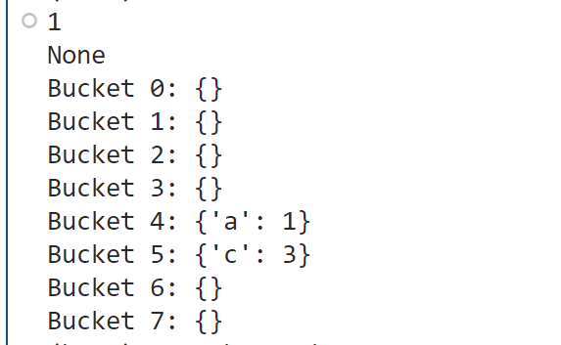

图 1 实验1测试结果

# 并发控制

## 2.1冲突可串行性判别算法

from collections import defaultdict, deque

def build_conflict_graph(schedule):

    # 构建冲突图

    conflict_graph = defaultdict(set)

    operations = []

    # 解析调度

    for operation in schedule:

        action, transaction, item = operation

        operations.append((action, transaction, item))

    # 记录每个事务对每个数据项的最后一次操作

    last_operations = defaultdict(lambda: defaultdict(tuple))

    for idx, (action, transaction, item) in enumerate(operations):

        if action == 'W':

            # 写操作

            if item in last_operations:

                for t, op_idx in last_operations[item].items():

                    if t != transaction:

                        conflict_graph[t].add(transaction)

                        conflict_graph[transaction].add(t)

            last_operations[item][transaction] = (action, idx)

        elif action == 'R':

            # 读操作

            if item in last_operations:

                for t, (last_action, op_idx) in last_operations[item].items():

                    if t != transaction and last_action == 'W':

                        conflict_graph[t].add(transaction)

                        conflict_graph[transaction].add(t)

            last_operations[item][transaction] = (action, idx)

    return conflict_graph

def is_cyclic(conflict_graph):

    # 检测冲突图中是否存在环

    visited = set()

    recursion_stack = set()

    def dfs(node):

        visited.add(node)

        recursion_stack.add(node)

        for neighbor in conflict_graph[node]:

            if neighbor not in visited:

                if dfs(neighbor):

                    return True

            elif neighbor in recursion_stack:

                return True

        recursion_stack.remove(node)

        return False

    for node in conflict_graph:

        if node not in visited:

            if dfs(node):

                return True

    return False

def is_conflict_serializable(schedule):

    conflict_graph = build_conflict_graph(schedule)

    return not is_cyclic(conflict_graph)

# 示例使用

if __name__ == '__main__':

    schedule = [

        ('R', 'T1', 'B'),

        ('W', 'T1', 'B'),

        ('R', 'T2', 'A'),

        ('W', 'T2', 'B'),

        ('R', 'T3', 'B'),

        ('W', 'T3', 'A')

    ]

    print(schedule)

    if is_conflict_serializable(schedule):

        print("The schedule is conflict serializable.")

    else:

        print("The schedule is not conflict serializable.")

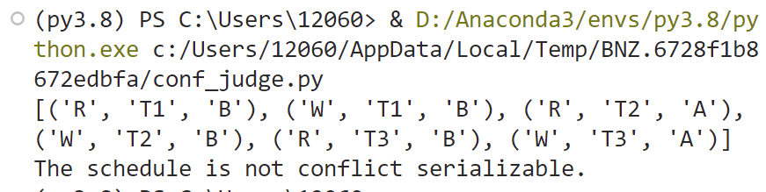

图 2 实验2.1测试结果

## 2.2 基于时间戳的并发控制算法

from collections import defaultdict

class TimestampBasedConcurrencyControl:

    def __init__(self):

        self.data_items = {}

        self.write_timestamps = {}

        self.read_locks = defaultdict(set)

        self.write_locks = {}

        self.transactions = {}

        self.next_timestamp = 0

    def start_transaction(self, transaction_id):

        self.transactions[transaction_id] = self.next_timestamp

        self.next_timestamp += 1

    def read(self, transaction_id, data_item):

        ts = self.transactions[transaction_id]

        if data_item in self.write_locks and self.write_locks[data_item] != transaction_id:

            print(f"Transaction {transaction_id} aborted due to write lock on {data_item}")

            return None

        if data_item in self.write_timestamps and self.write_timestamps[data_item] >= ts:

            print(f"Transaction {transaction_id} aborted due to write timestamp on {data_item}")

            return None

        self.read_locks[data_item].add(transaction_id)

        return self.data_items.get(data_item, None)

    def write(self, transaction_id, data_item, value):

        ts = self.transactions[transaction_id]

        if data_item in self.write_locks and self.write_locks[data_item] != transaction_id:

            print(f"Transaction {transaction_id} aborted due to write lock on {data_item}")

            return False

        if data_item in self.write_timestamps and self.write_timestamps[data_item] >= ts:

            print(f"Transaction {transaction_id} aborted due to write timestamp on {data_item}")

            return False

        if data_item in self.read_locks and any(t != transaction_id for t in self.read_locks[data_item]):

            print(f"Transaction {transaction_id} aborted due to read lock on {data_item}")

            return False

        self.write_locks[data_item] = transaction_id

        self.data_items[data_item] = value

        self.write_timestamps[data_item] = ts

        return True

    def commit(self, transaction_id):

        for data_item in list(self.read_locks.keys()):

            if transaction_id in self.read_locks[data_item]:

                self.read_locks[data_item].remove(transaction_id)

                if not self.read_locks[data_item]:

                    del self.read_locks[data_item]

        if transaction_id in self.write_locks.values():

            for data_item, tid in list(self.write_locks.items()):

                if tid == transaction_id:

                    del self.write_locks[data_item]

        del self.transactions[transaction_id]

        print(f"Transaction {transaction_id} committed")

    def abort(self, transaction_id):

        for data_item in list(self.read_locks.keys()):

            if transaction_id in self.read_locks[data_item]:

                self.read_locks[data_item].remove(transaction_id)

                if not self.read_locks[data_item]:

                    del self.read_locks[data_item]

        if transaction_id in self.write_locks.values():

            for data_item, tid in list(self.write_locks.items()):

                if tid == transaction_id:

                    del self.write_locks[data_item]

        del self.transactions[transaction_id]

        print(f"Transaction {transaction_id} aborted")

# 示例使用

if __name__ == '__main__':

    tcc = TimestampBasedConcurrencyControl()

    tcc.start_transaction('T1')

    tcc.start_transaction('T2')

    tcc.start_transaction('T3')

    print(tcc.read('T1', 'A'))

    tcc.write('T1', 'A', 10)

    print(tcc.read('T2', 'A'))

    tcc.write('T2', 'A', 20)

    print(tcc.read('T3', 'A'))

    tcc.write('T3', 'A', 30)

    tcc.commit('T1')

    tcc.abort('T2')

tcc.abort('T3')

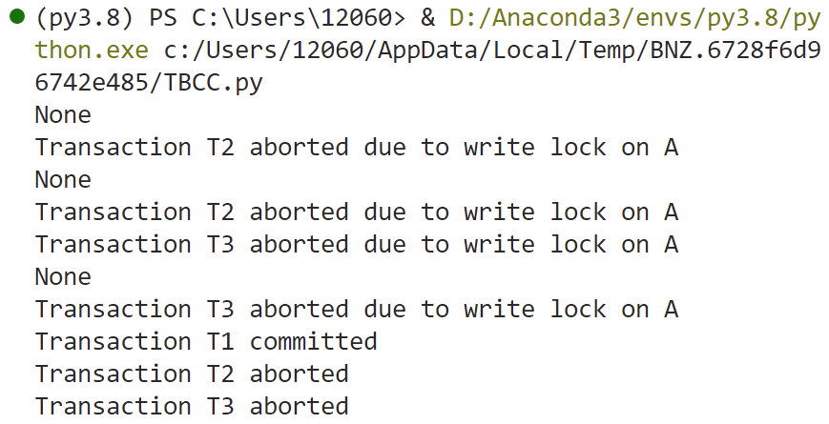

图 3 实验2.2测试结果

# 3．完成Paxos协议的代码实现与测试

import random

import threading

import time

class Proposer:

    def __init__(self, proposer_id, acceptors, learners):

        self.proposer_id = proposer_id

        self.acceptors = acceptors

        self.learners = learners

        self.n = 0

        self.value = None

        self.majority = len(acceptors) // 2 + 1

    def propose(self, value):

        self.value = value

        self.n += 1

        self.prepare()

    def prepare(self):

        print(f"Proposer {self.proposer_id} sending prepare({self.n})")

        responses = []

        for acceptor in self.acceptors:

            response = acceptor.receive_prepare(self.n)

            if response:

                responses.append(response)

            if len(responses) >= self.majority:

                break

        if len(responses) >= self.majority:

            self.accept(responses)

    def accept(self, responses):

        max_n = -1

        max_value = None

        for n, value in responses:

            if n > max_n:

                max_n = n

                max_value = value

        value = max_value if max_value is not None else self.value

        print(f"Proposer {self.proposer_id} sending accept({self.n}, {value})")

        responses = []

        for acceptor in self.acceptors:

            response = acceptor.receive_accept(self.n, value)

            if response:

                responses.append(response)

            if len(responses) >= self.majority:

                break

        if len(responses) >= self.majority:

            self.learn(value)

    def learn(self, value):

        print(f"Proposer {self.proposer_id} learned value {value}")

        for learner in self.learners:

            learner.learn(value)

class Acceptor:

    def __init__(self, acceptor_id):

        self.acceptor_id = acceptor_id

        self.promised_n = -1

        self.accepted_n = -1

        self.accepted_value = None

    def receive_prepare(self, n):

        if n > self.promised_n:

            self.promised_n = n

            print(f"Acceptor {self.acceptor_id} promised {n}")

            return (self.accepted_n, self.accepted_value)

        print(f"Acceptor {self.acceptor_id} rejected prepare({n})")

        return None

    def receive_accept(self, n, value):

        if n >= self.promised_n:

            self.accepted_n = n

            self.accepted_value = value

            print(f"Acceptor {self.acceptor_id} accepted ({n}, {value})")

            return True

        print(f"Acceptor {self.acceptor_id} rejected accept({n}, {value})")

        return False

class Learner:

    def __init__(self, learner_id):

        self.learner_id = learner_id

    def learn(self, value):

        print(f"Learner {self.learner_id} learned value {value}")

# 示例使用

if __name__ == '__main__':

    # 创建 Acceptors

    acceptors = [Acceptor(i) for i in range(3)]

    # 创建 Learners

    learners = [Learner(i) for i in range(2)]

    # 创建 Proposers

    proposers = [Proposer(i, acceptors, learners) for i in range(2)]

    # 启动 Proposers

    threads = []

    for proposer in proposers:

        thread = threading.Thread(target=proposer.propose, args=(random.randint(1, 100),))

        threads.append(thread)

        thread.start()

    # 等待所有 Proposers 完成

    for thread in threads:

        thread.join()

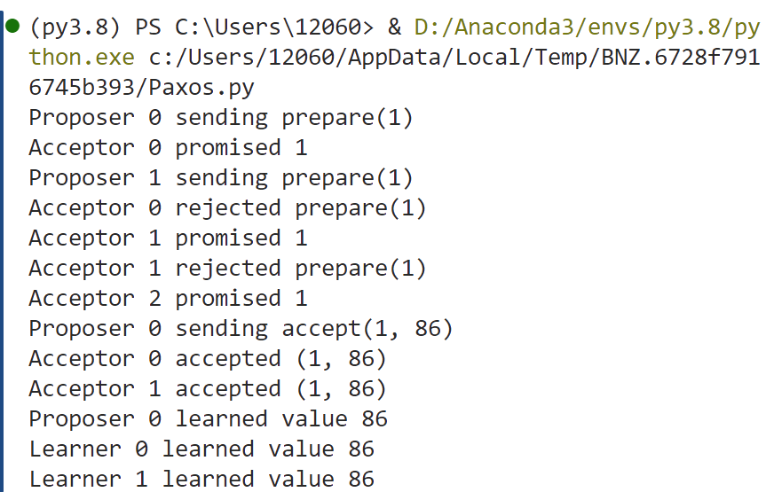

图 4 实验3测试结果